Task 5.2: Implement ORM to Map the database table using JPA annotations such as @Entity, @Id, @Table, and @Column in a student class.
STEP 1: Create Spring Boot Project
- Go to File → New → Spring Starter Project
- Fill details:
Field | Value
Name | studentapp
Type | Maven
Packaging | Jar
Java | 17 (or your version)
Group | com.example
Artifact | demo
Package | com.example.demo
Click Next
Add Dependencies
Select:
- Spring Web
- Spring Data JPA
- MySQL Driver
Click Finish
Project Structure Image:
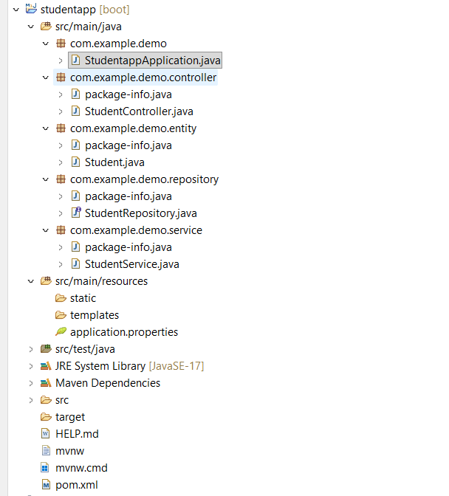

Pom.xml:
<?xml version="1.0" encoding="UTF-8"?>
<project xmlns="http://maven.apache.org/POM/4.0.0" xmlns:xsi="http://www.w3.org/2001/XMLSchema-instance"
xsi:schemaLocation="http://maven.apache.org/POM/4.0.0 https://maven.apache.org/xsd/maven-4.0.0.xsd">
<modelVersion>4.0.0</modelVersion>
<parent>
<groupId>org.springframework.boot</groupId>
<artifactId>spring-boot-starter-parent</artifactId>
<version>4.0.3</version>
<relativePath/> <!-- lookup parent from repository -->
</parent>
<groupId>com.example</groupId>
<artifactId>demo</artifactId>
<version>0.0.1-SNAPSHOT</version>
<name>studentapp</name>
<description>Demo project for Spring Boot</description>
<url/>
<licenses>
<license/>
</licenses>
<developers>
<developer/>
</developers>
<scm>
<connection/>
<developerConnection/>
<tag/>
<url/>
</scm>
<properties>
<java.version>17</java.version>
</properties>
<dependencies>
<dependency>
<groupId>org.springframework.boot</groupId>
<artifactId>spring-boot-starter-data-jpa</artifactId>
</dependency>
<dependency>
<groupId>org.springframework.boot</groupId>
<artifactId>spring-boot-starter-webmvc</artifactId>
</dependency>
<dependency>
<groupId>com.mysql</groupId>
<artifactId>mysql-connector-j</artifactId>
<scope>runtime</scope>
</dependency>
<dependency>
<groupId>org.springframework.boot</groupId>
<artifactId>spring-boot-starter-data-jpa-test</artifactId>
<scope>test</scope>
</dependency>
<dependency>
<groupId>org.springframework.boot</groupId>
<artifactId>spring-boot-starter-webmvc-test</artifactId>
<scope>test</scope>
</dependency>
</dependencies>
<build>
<plugins>
<plugin>
<groupId>org.springframework.boot</groupId>
<artifactId>spring-boot-maven-plugin</artifactId>
</plugin>
</plugins>
</build>
</project>
STEP 2: Configure Database
src/main/resources/application.properties

STEP 3: Create Database in MySQL
CREATE DATABASE studentdb;

STEP 4: Create Package Structure
com.example.demo
├── controller
├── service
├── repository
└── entity
Right click → New → Package
STEP 5: Create Student Entity Class
Package: entity
Right click → New → Class → Name: Student
package com.example.demo.entity;
import jakarta.persistence.*;
@Entity
@Table(name = "students")
public class Student {
@Id
@GeneratedValue(strategy = GenerationType.IDENTITY)
@Column(name = "student_id")
private Long id;
@Column(name = "student_name", nullable = false)
private String name;
@Column(name = "student_email", unique = true)
private String email;
@Column(name = "student_age")
private int age;
// Default Constructor
public Student() {}
// Parameterized Constructor
public Student(String name, String email, int age) {
this.name = name;
this.email = email;
this.age = age;
}
// Getters & Setters
public Long getId() { return id; }
public void setId(Long id) { this.id = id; }
public String getName() { return name; }
public void setName(String name) { this.name = name; }
public String getEmail() { return email; }
public void setEmail(String email) { this.email = email; }
public int getAge() { return age; }
public void setAge(int age) { this.age = age; }
}
STEP 6: Create Repository Layer
Package: repository
Create Interface → StudentRepository
package com.example.demo.repository;
import org.springframework.data.jpa.repository.JpaRepository;
import com.example.demo.entity.Student;
public interface StudentRepository extends JpaRepository<Student, Long> {
}
STEP 7: Create Service Layer
Package: service
Create Class → StudentService
package com.example.demo.service;

import java.util.List;
import org.springframework.beans.factory.annotation.Autowired;
import org.springframework.stereotype.Service;
import com.example.demo.entity.Student;
import com.example.demo.repository.StudentRepository;
@Service
public class StudentService {
@Autowired
private StudentRepository repository;
public Student saveStudent(Student student) {
return repository.save(student);
}
public List<Student> getAllStudents() {
return repository.findAll();
}
}
STEP 8: Create Controller Layer
Package: controller
Create Class → StudentController
package com.example.demo.controller;
import java.util.List;
import org.springframework.beans.factory.annotation.Autowired;
import org.springframework.web.bind.annotation.*;
import com.example.demo.entity.Student;
import com.example.demo.service.StudentService;
@RestController
@RequestMapping("/students")
public class StudentController {
@Autowired
private StudentService service;
@PostMapping
public Student createStudent(@RequestBody Student student) {
return service.saveStudent(student);
}
@GetMapping
public List<Student> getStudents() {
return service.getAllStudents();
}
}
STEP 9: Run Using Main Class
src/main/java → com.example.demo →StudentappApplication.java
Right click : Run As → Java Application
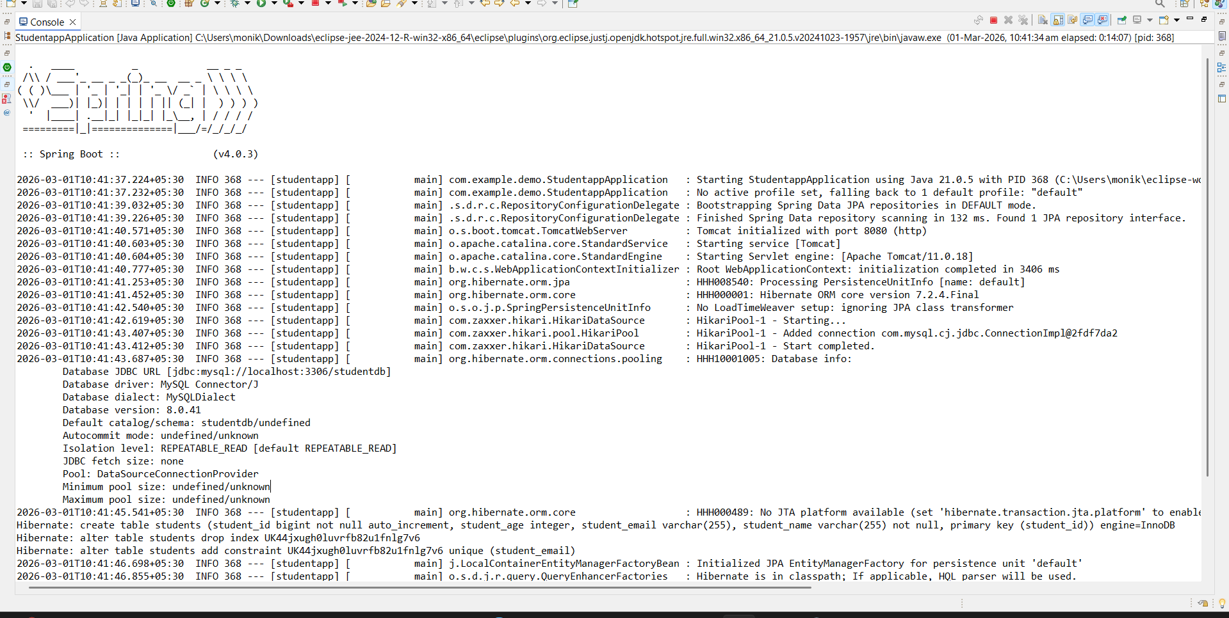

STEP 10:Postman
Open Postman
http://localhost:8080/students
Method: POST
Body → raw → JSON:
{
"name": "Mounika",
"email": "mounika@gmail.com",
"age": 22
}
Click: Send button
NOW:verification
Change to Get Method: Send
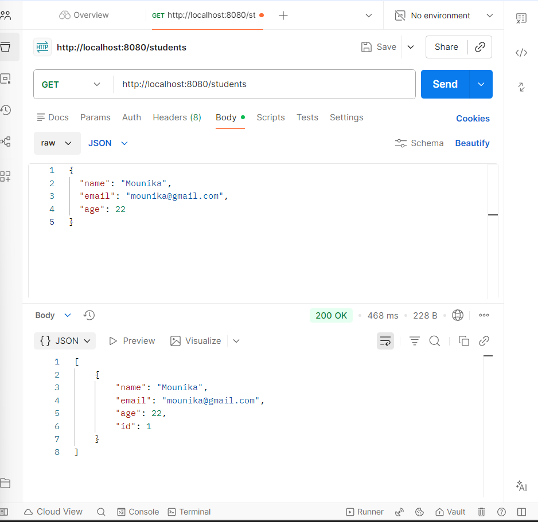

STEP 11: In MySQL
